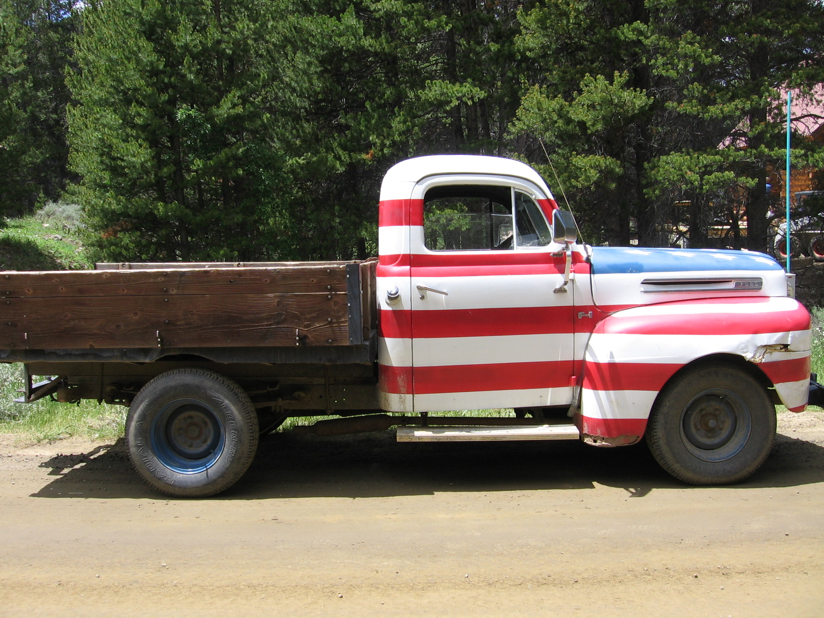
HRS: History Reading Summary Name ________________
Chapter ____ Section____

1. Skim: Preview the reading assignment (review headings, terms, pictures, etc.). 2 pts BEFORE
• What do you think you will be learning from this assignment?

• What questions do you have?

2. Make Connections: List and describe what you already know about this topic. 1 pt BEFORE
Example: Have you seen any movies about this time period? Do you know anyone that lived through it? Have you read any books related to this time period or visited any locations connected to the topic?

3. Summarize: Describe the key events and people presented in this reading (number your list).
Include at least 6 descriptions. 3 pts DURING

3. continued from page 1
Summarize: Describe the key events and people presented in this reading (number your list). DURING

5. Thinking Forward: Reflect on what you learned from this reading assignment. 2 pts AFTER
• Write at least one question you still have about this material.

• Also, write at least one test question and the correct answer you would expect to see on a test over this material.

4. Making connections: Explain how this reading relates to at least one of this unit’s Big Ideas or Important Questions. (Refer to our Important Questions & Big Ideas sheet for this unit and specifically connect to one of them.) AFTER
The Important Questions are the same questions you will have to write short answers about for each unit test so the more comfortable you are with them the better!) 2 pts.

